7

# The Habits Applications for Managers

**January 28-29, 2014**

**8:30 am – 5: 30 pm**

**Venue: Holiday Inn, Mimosa Leisure Estate Mimosa Drive, Clark Freeport Zone, Pampanga**

**WORKSHOP IS INCLUSIVE OF:**

The 7 Habits for Managers Toolkit, Workshop Certificate and

AM/PM Snacks/Lunch

*Brought to you by:*



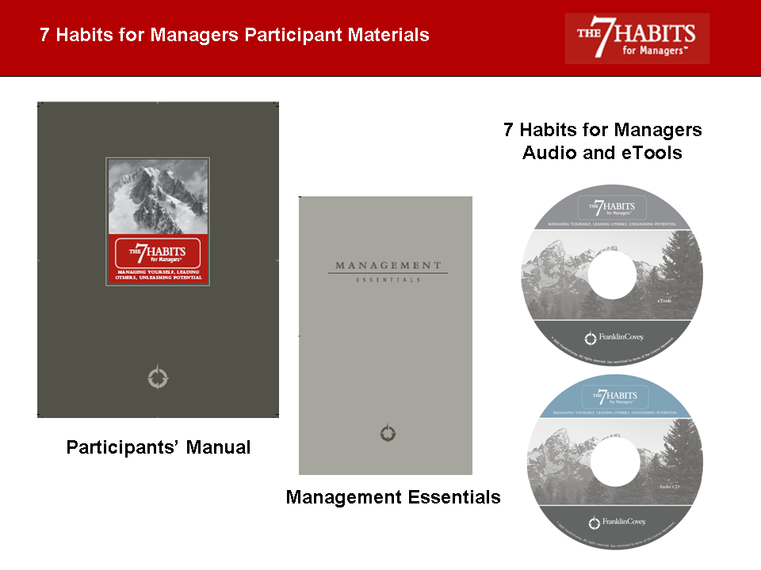

*in partnership with:*

**CHRC**

RESERVATION FORM

|  |  |
| --- | --- |
| **AMOUNT** | **GROSS RATE (w/ 12% VAT)** |
| 16,000.00 | 17,920.00 |
| *CHRC Members who will register for the workshop will get a FranklinCovey Multifunction Pen*  *(Retail Price of the Pen at the FranklinCovey Store: Php1,090.00)* | |

###### *Participant Information (Please Print):*

Workshop Date: _________________________________ Date Today: _________________________________________

Full Name:_________________________________________________ Nickname: _______________________________

Position: ______________________________ Company Name: ______________________________________________

Address:___________________________________________________________________________________________

Tel. No:_____________________Fax No:______________________E-Mail Address:______________________________

Cell Phone No: _________________________Birth Date: ______________________

Authorizing Officer: ___________________________________Position:________________________________________

Signature of Authorizing Officer:___________________________________________

How did you learn about this workshop? ___ CHRC ___ CLCI ___ Referral ___ Others (pls. specify):__---__________

1. *Please note that seats are limited. Thus, to give equal opportunity to those who want to attend the workshop, participants are only considered confirmed upon submission of the signed and approved reservation form and receipt of the 50% DP by Clark HR Council (CHRC). In case of cancellations/postponements two weeks before the workshop dates, a 50% cancellation/postponement fee will be charged to the participant. However, a substitute delegate is allowed.*
2. *Workshop schedules are subject to change.*
3. *Please make cash or check payments through CHRC. Checks should be made payable to Center for Leadership and Change, Inc.*



|  |
| --- |
| **Email or Fax Reservation Form to CHRC: (045)599-2045/499-2245; <labor@clark.com.ph>, <clarkhumanresource@gmail.com>** |